**Binary Trie**

**\\ Base code //**

**\\ Add code //**

**\\ Erase code //**

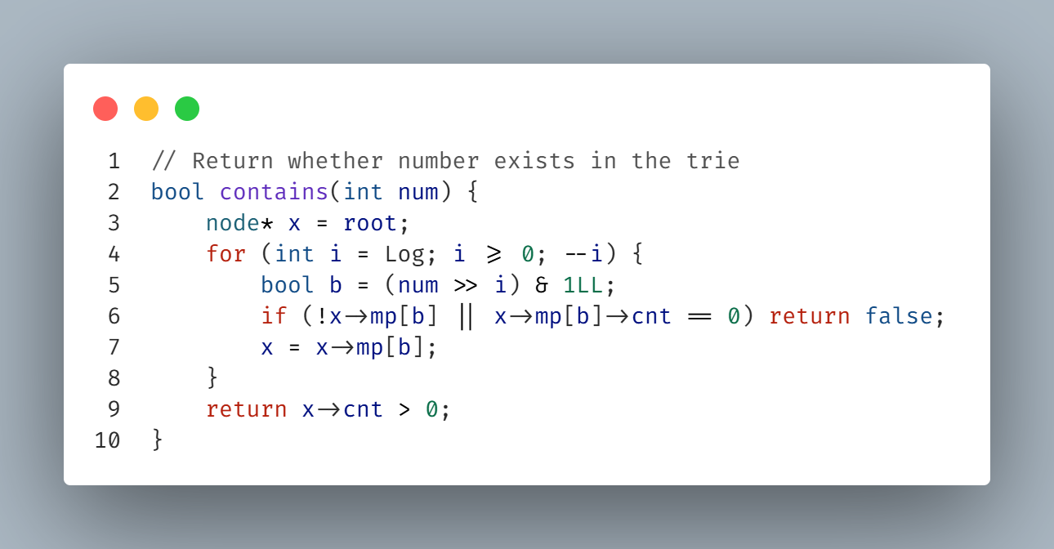**\\ Contains code //**

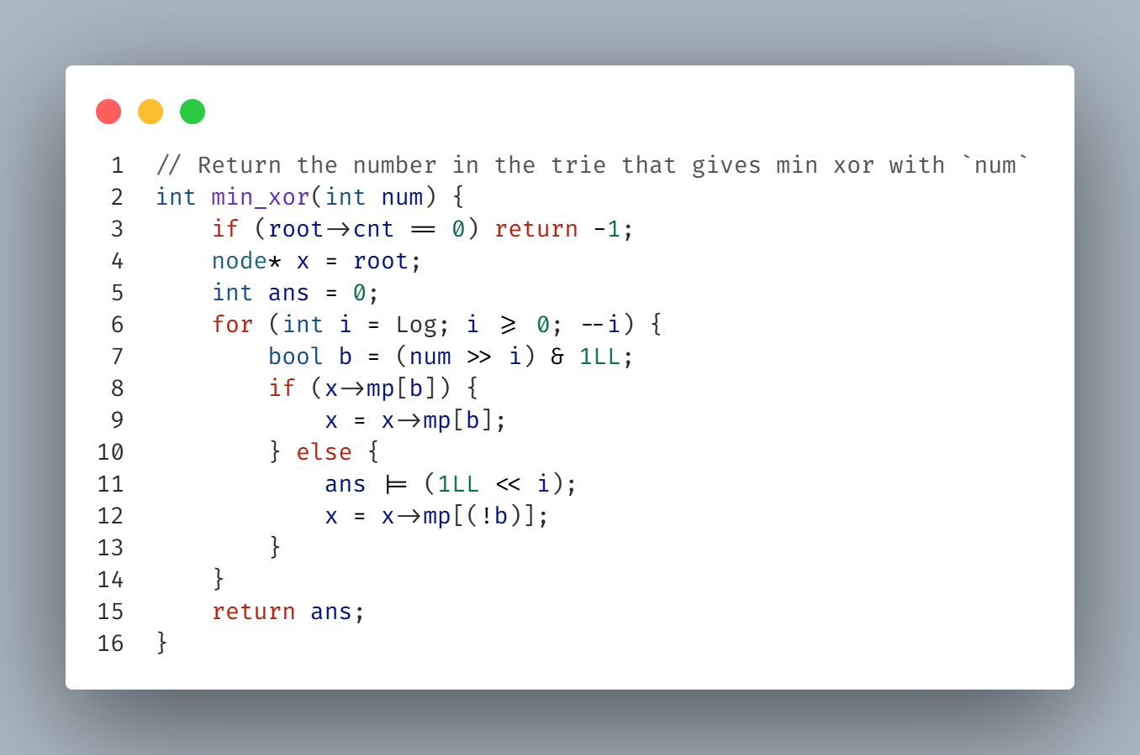 **\\ Min XOR code //**

**\\ Max XOR code //**

**Trie String**

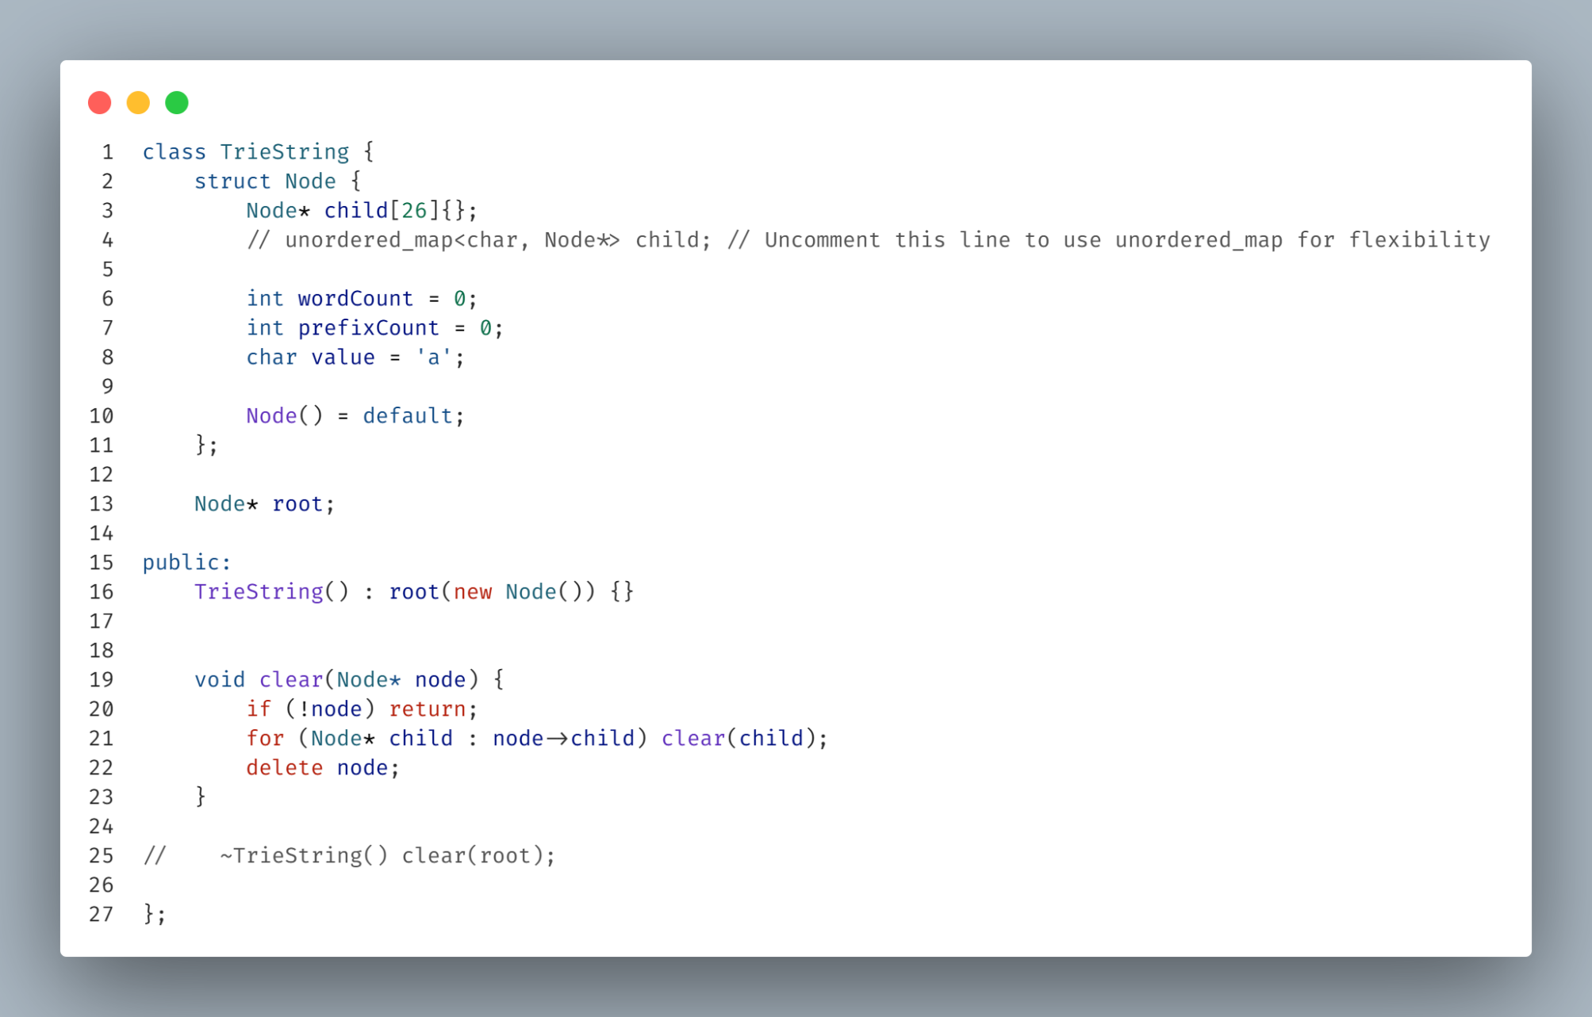**\\ Base code //**

**\\ Insert code //**

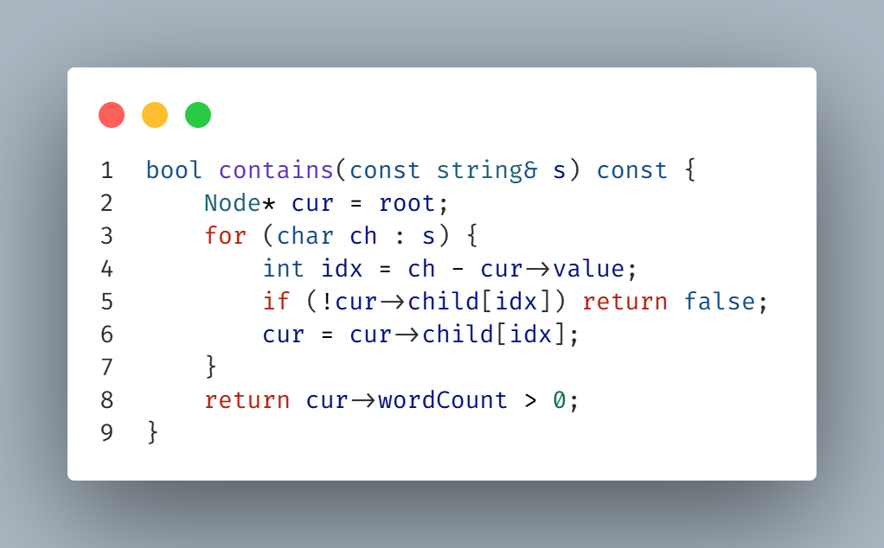**\\ Contains code //**

**\\ Count words code //**

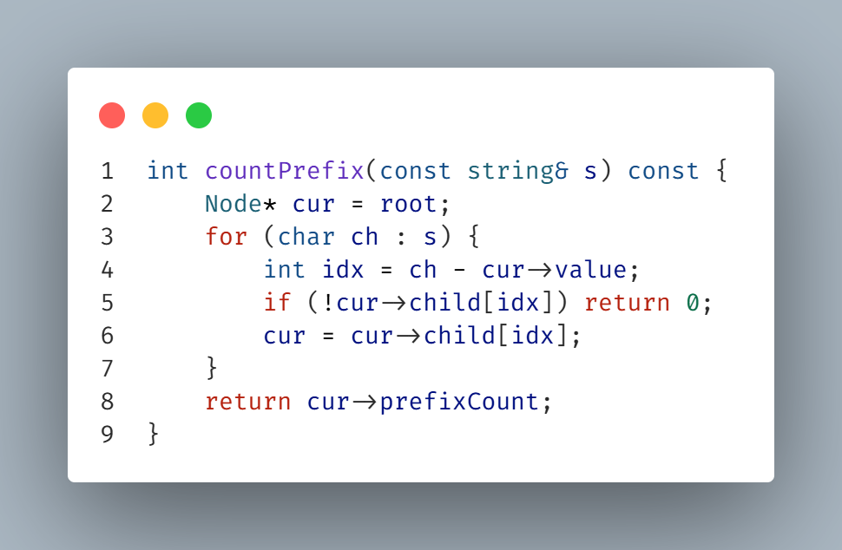**\\ Count prefix code //**

**\\ Erase code //**

**Sum Of All**

**Sparse Table**

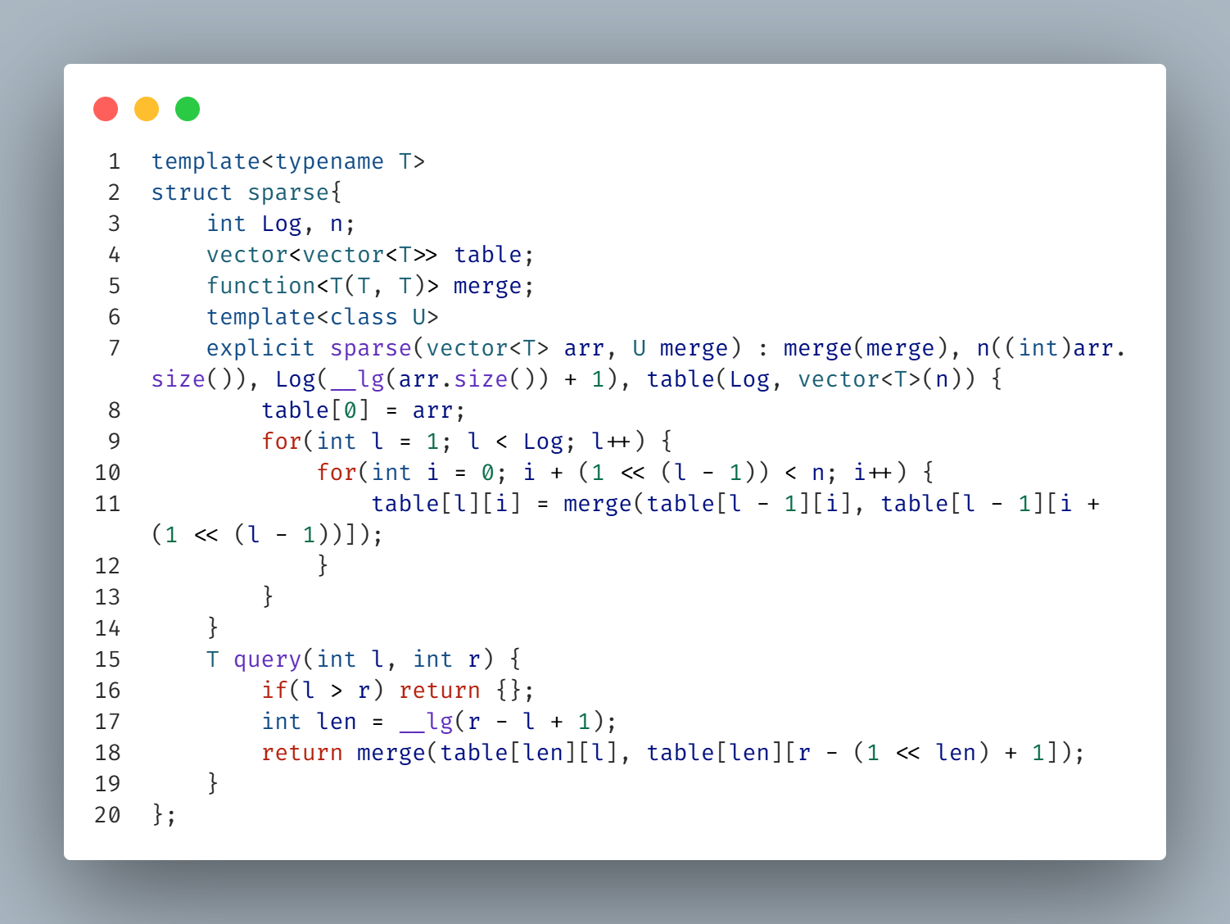**\\ All The code //**

**\\ How to use //**

**BIT**

**BIT Range**

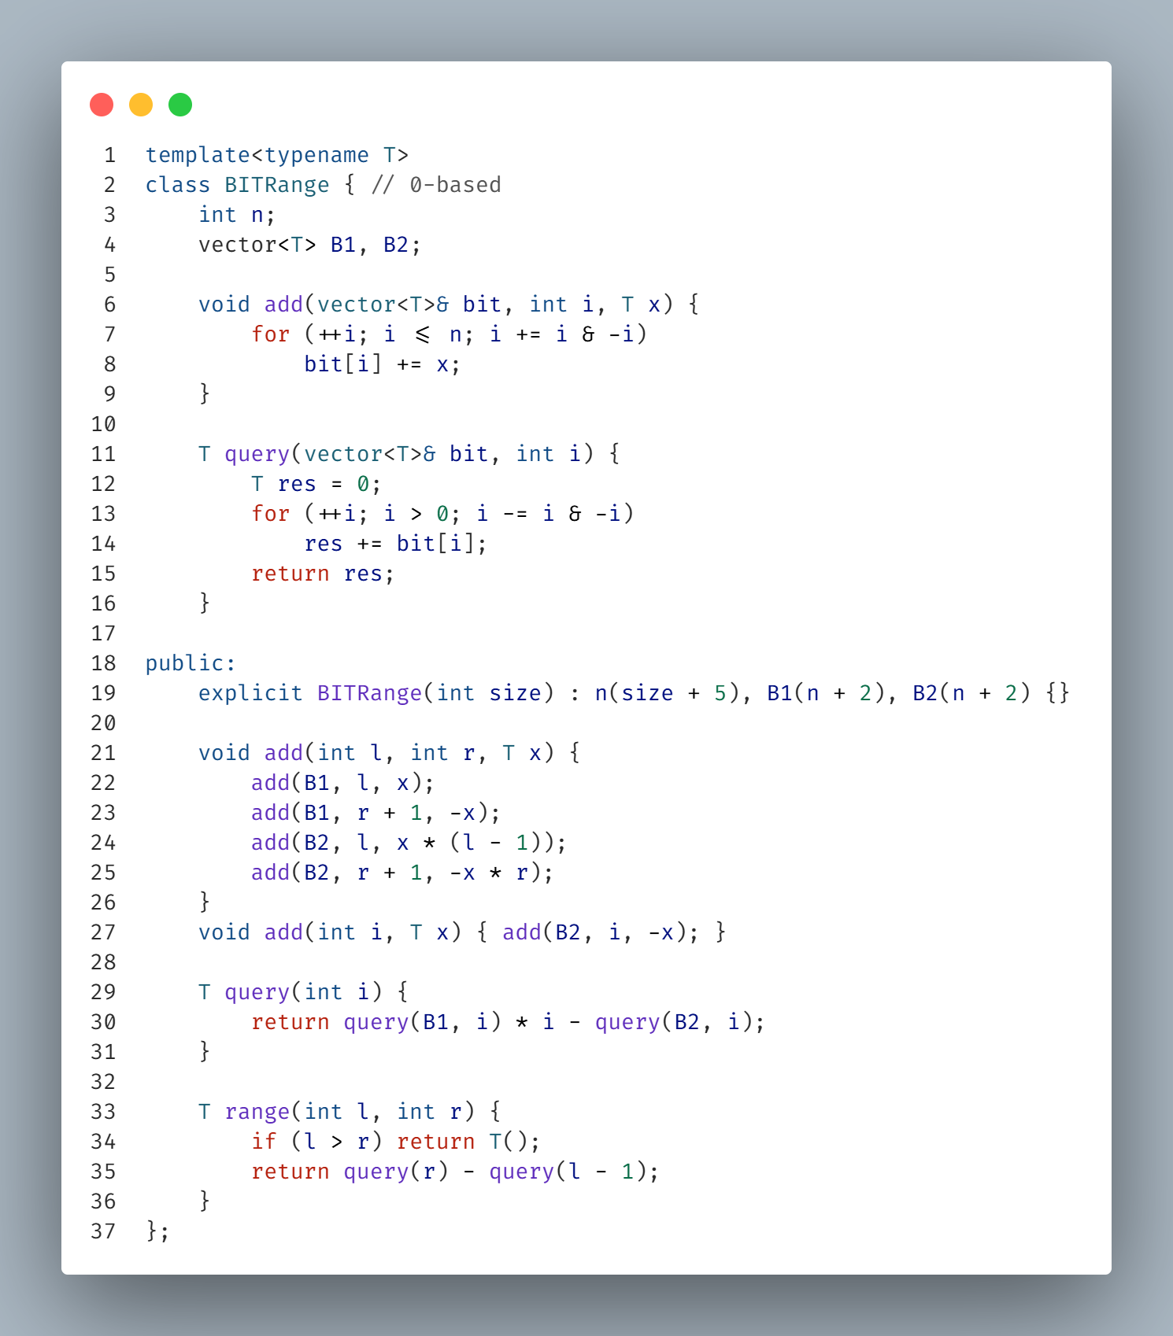

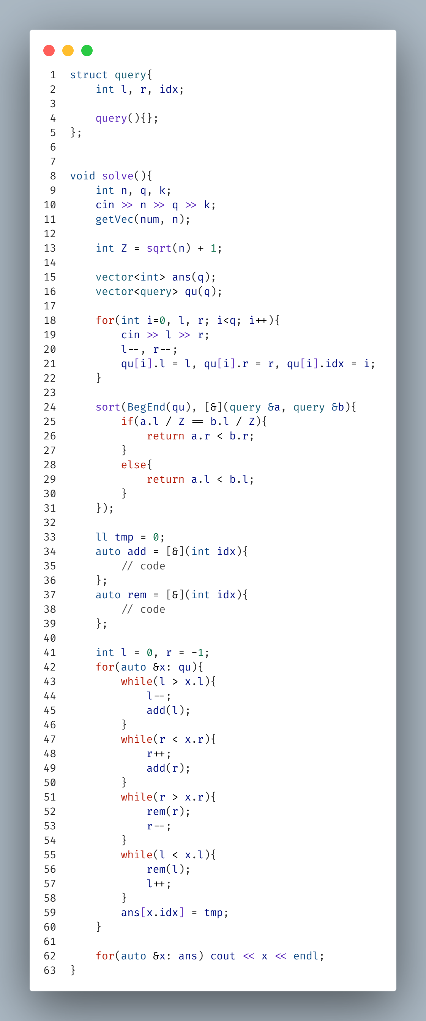**SQRT & MO**